Kortext login for first time users

1. Click on the *Online access* link in the catalogue or access the ebook from your reading list or via a direct link.

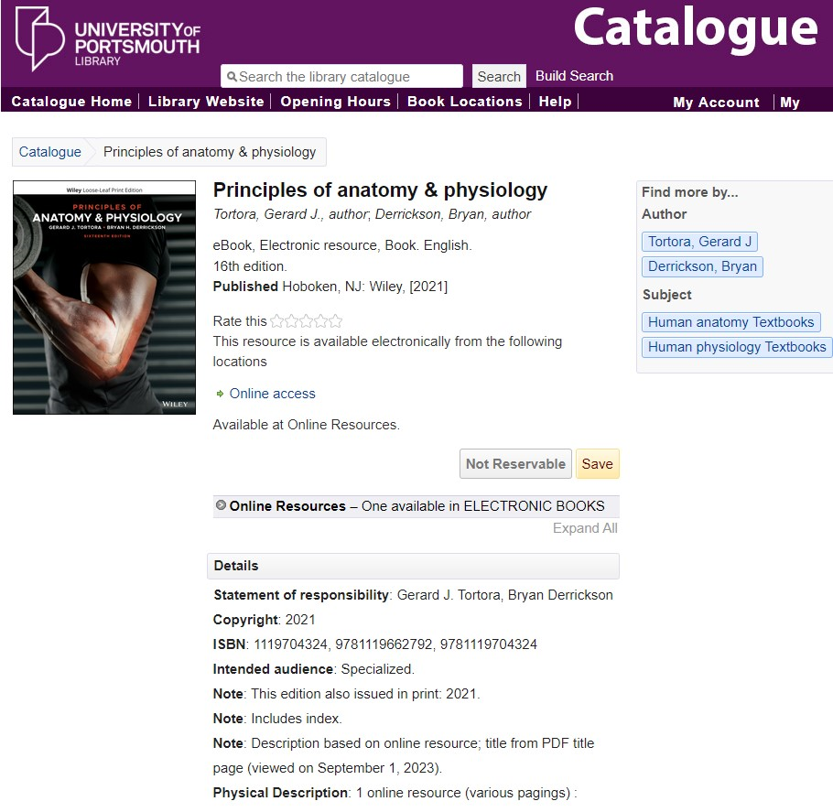

2. Enter your University login details. You may have to do this twice.

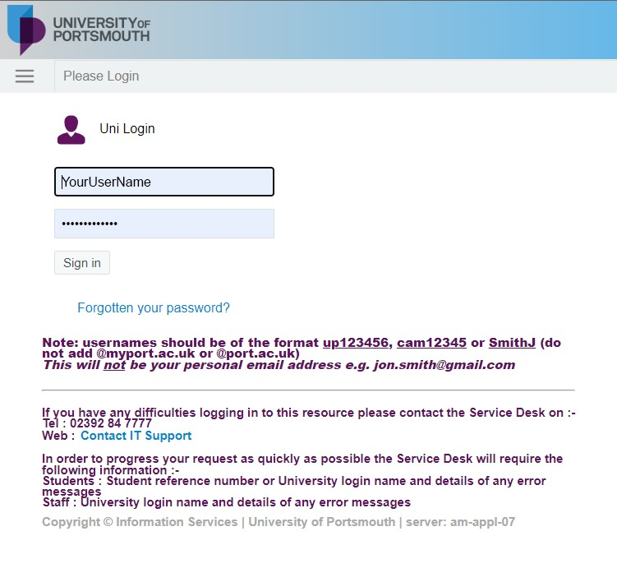

3. You must register for an account. Enter your University email address and make up a password of your choosing. Then click on *Access my textbook*.

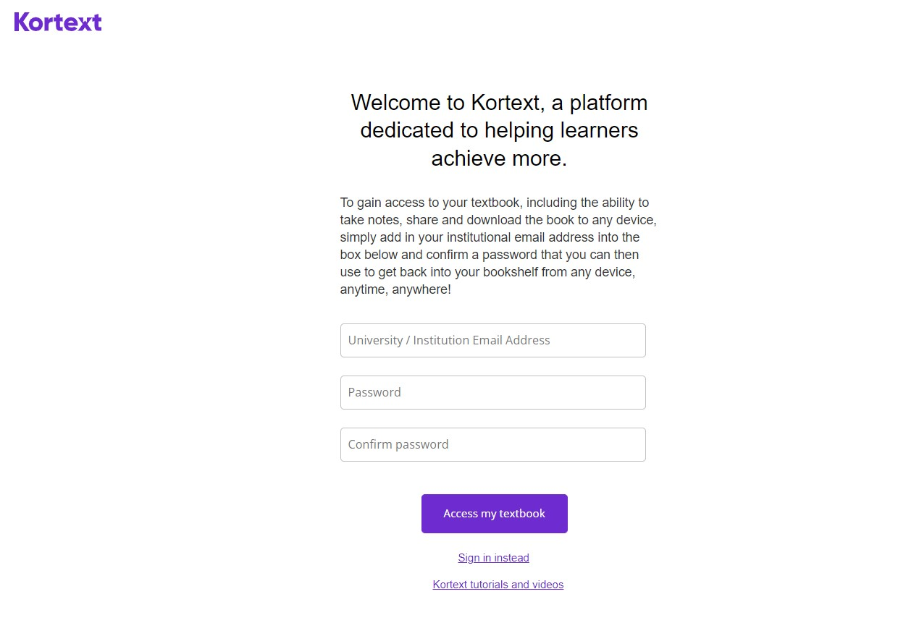

4. Agree to the terms and conditions and click on *Sign in*.

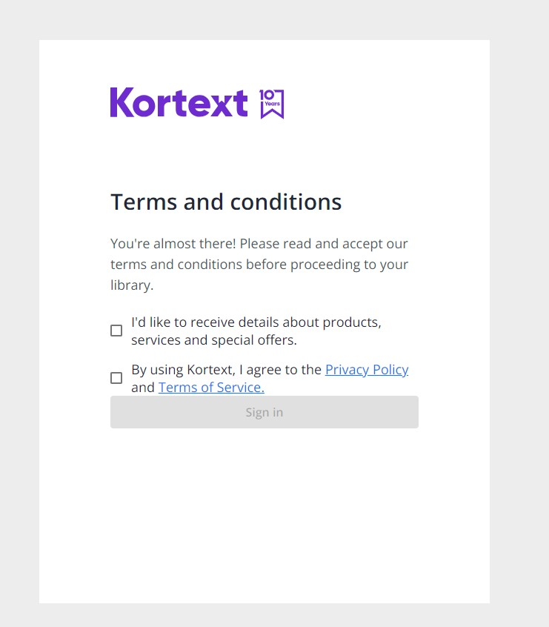

5. This will take you into the book.

