 Editing Talis Aspire Online Reading Lists

# Introduction

Talis is the name of the company who provide our online reading list system, Aspire. If you create your reading list in Aspire, it means that the information is available to library staff and they can alert you to any problems or even replace e-books automatically if they become unavailable for any reason. Once your list is ready, you can go into Moodle and link in sections of the list to weekly or thematic sections in Moodle. This linking means that the reading updates automatically in Moodle if anything is updated in Aspire. This video gives you a quick overview:

<https://port.cloud.panopto.eu/Panopto/Pages/Viewer.aspx?id=03777a62-de0b-4ae2-b042-b16400c75e16>

# Getting Started

Tell your Faculty Librarian which modules you co-ordinate. You will then receive an email/s from Talis Aspire inviting you to become a “List Publisher”. Follow the instructions in the message to accept the invitation.

## 2.1 Set Up a Profile

(You only need to do this when setting up your account.)

1. When you are following through the set-up steps you will be asked to create a profile. Here you should add useful information e.g. an academic. Opt to make the profile public so that students see your name on each list.
2. When you are done, click the button at the bottom labelled **Save profile.**

If you want to edit your profile later, just click your name towards the top centre of the screen.

# Finding the Reading List Software & Installing the Bookmarking Extension

1. Start at the **Library home page** library.port.ac.uk Choose **Using** **Resources** in the dark purple bar near the top of the screen, then click **Reading Lists** in the drop-down. (You can also log in at <https://port.rl.talis.com/index.html> )
2. If this is the first time using Aspire at work or at home, you will need to install a browser extension to bookmark items you want to add to your reading lists – this is **not the same** as bookmarking favourite websites. (If you’ve got the browser extension/bookmarks set up and want to work on the reading lists, click **My Lists** on the far right of the Library’s Reading Lists page.)
3. To **install the browser bookmark extension in Chrome** do a Google search for Talis Aspire bookmark extensionand select [Talis Aspire Reading Lists Bookmarking](https://chrome.google.com/webstore/detail/talis-aspire-reading-list/mmkenhijminadaklkpdhofkjfhglnokp). Click the **Add to Chrome** button towards the top right, then **Add extension** (see screenshots on next page) – there is also a video you can watch on the page you arrive at:

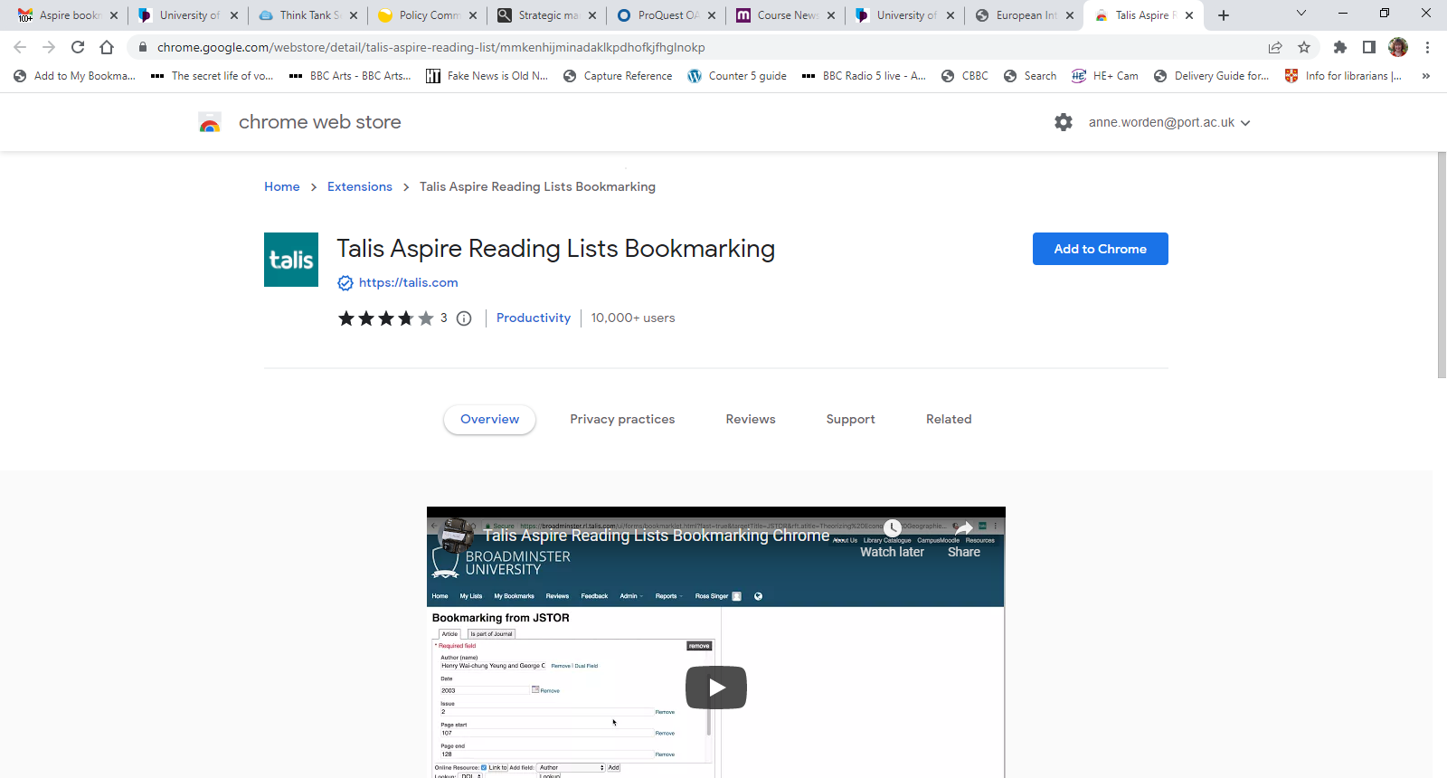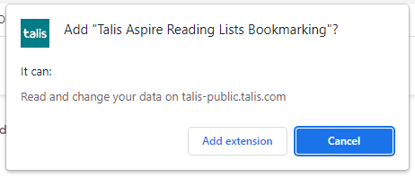

1. If you are using the Safari, Edge or Firefox browsers, you need to use [these instructions](https://support.talis.com/hc/en-us/articles/360000415058-Installing-the-bookmarklet-extensions-for-Microsoft-Edge-Chrome-and-Firefox-) for installing the browser extension.

# Starting Work on Your List

1. Check to see if your list already exists. At the Library homepage choose **Using** **Resources** in the purple bar near the top, then click **Reading Lists** from the drop-down**.**
2. Click **My Lists** in the **box on the right** and **if you can’t see the list needed**, click **Home** in the dark blue bar near the top of the screen**,** thentype the name of your list or module number into the search box in the middle of the screen.
3. When your list appears, click the name (make sure it has **List** next to it rather than Module). Click **+ My Lists** at the top right of the screen. When you click **My Lists** your module should now appear so you can edit or access it easily - My Lists at the right will now have a tick next to it as shown here:

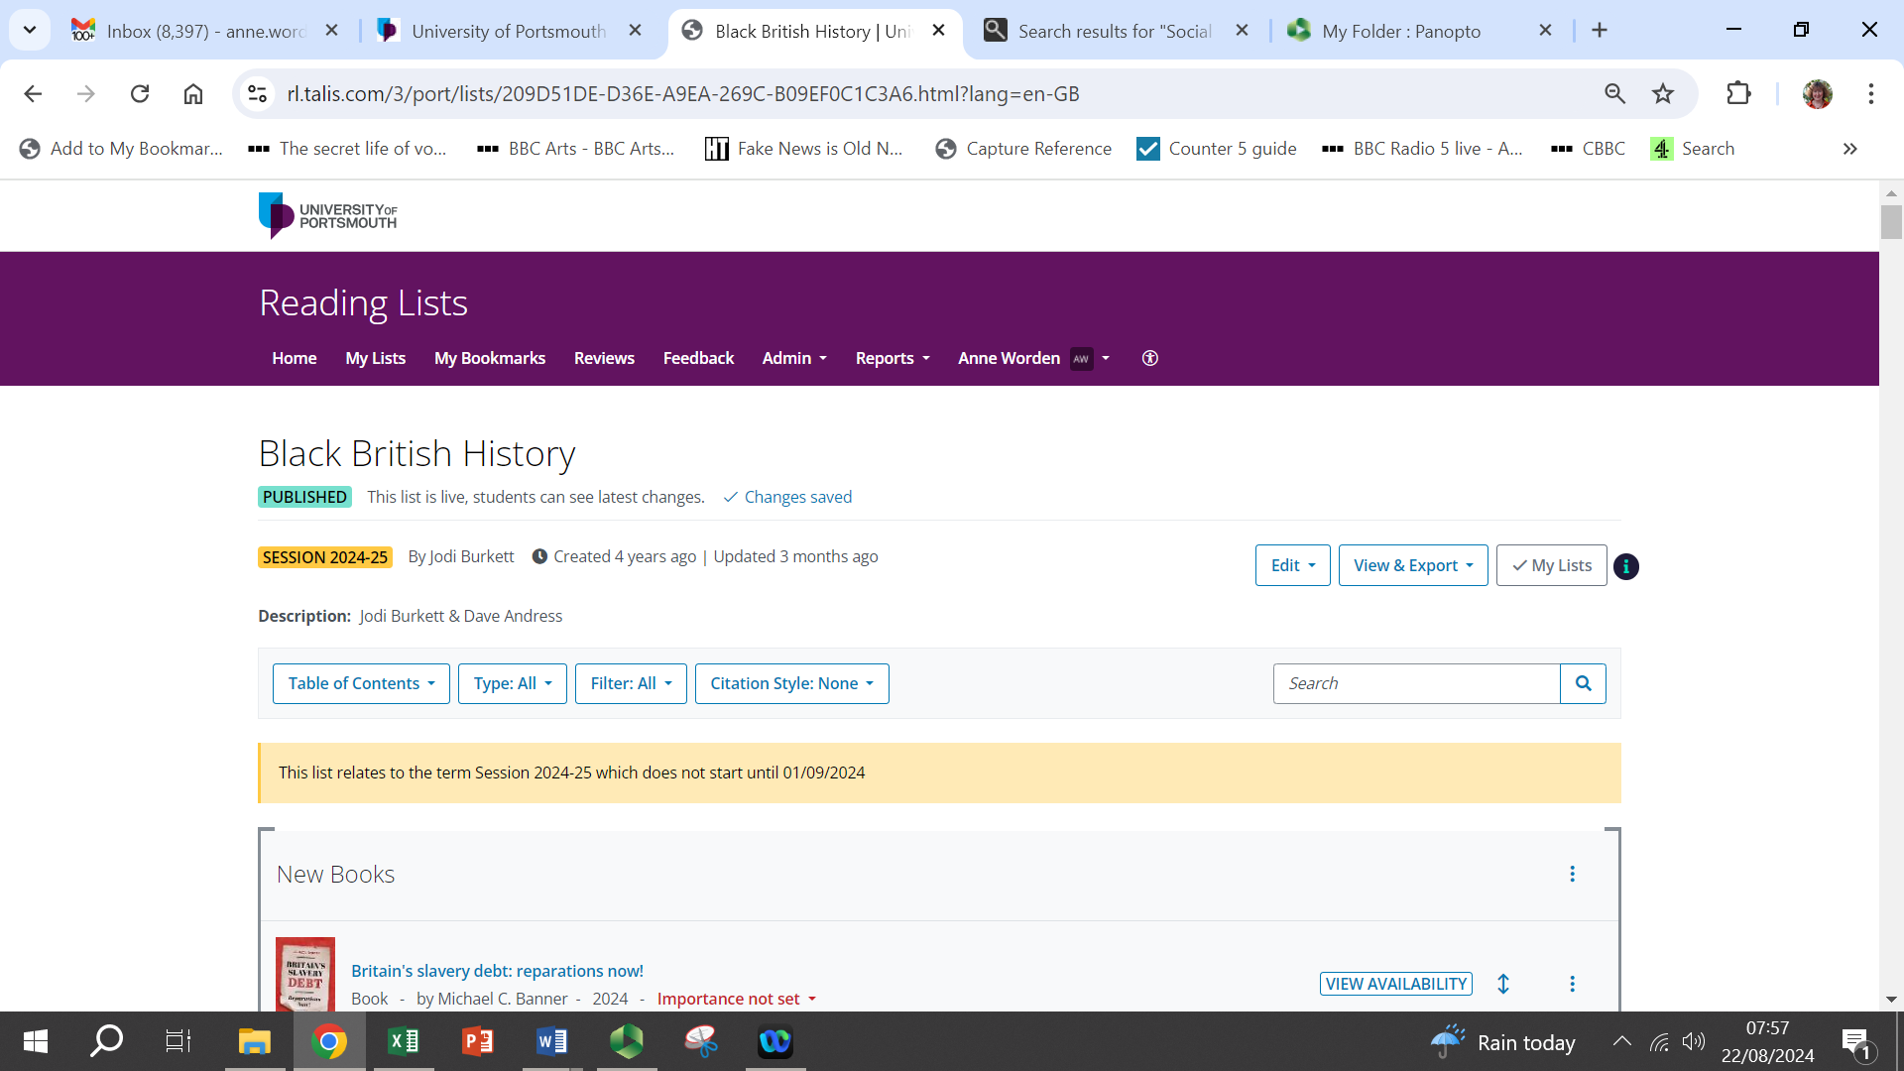

# Editing Your List

1. Although you can see an Edit button at the top right of your reading list, you don’t need to click this most of the time. Instead, just scroll through your list and **as you scroll, you’ll see a long line appear across the screen**. The 2 options in this line which you’ll use most often are **Add Resource** and **Add Section** (see screenshot below).
2. Click **Add Section**, then fill in the Title box etc which appear as shown in the next screen shot. Sections can be your weekly or theme headings and you can embed sections within sections if you want to indicate essential reading in 1 block and further reading in a 2nd block within a section.

The sections you add will form the **Table of Contents** (top left of your list). This is a great way of quickly jumping to sections further down your list and it also allows you or Online Course Developers to **embed the sections into weekly blocks on Moodle using Moodle’s Add an activity or resource** (then choose **Talis** in the list). There are full details about this in section 8 of this guide (pp. 9-12) and [this video](https://port.cloud.panopto.eu/Panopto/Pages/Viewer.aspx?id=bc305fe2-8d75-4ec8-b4f6-b075007141d6) also explains the process.

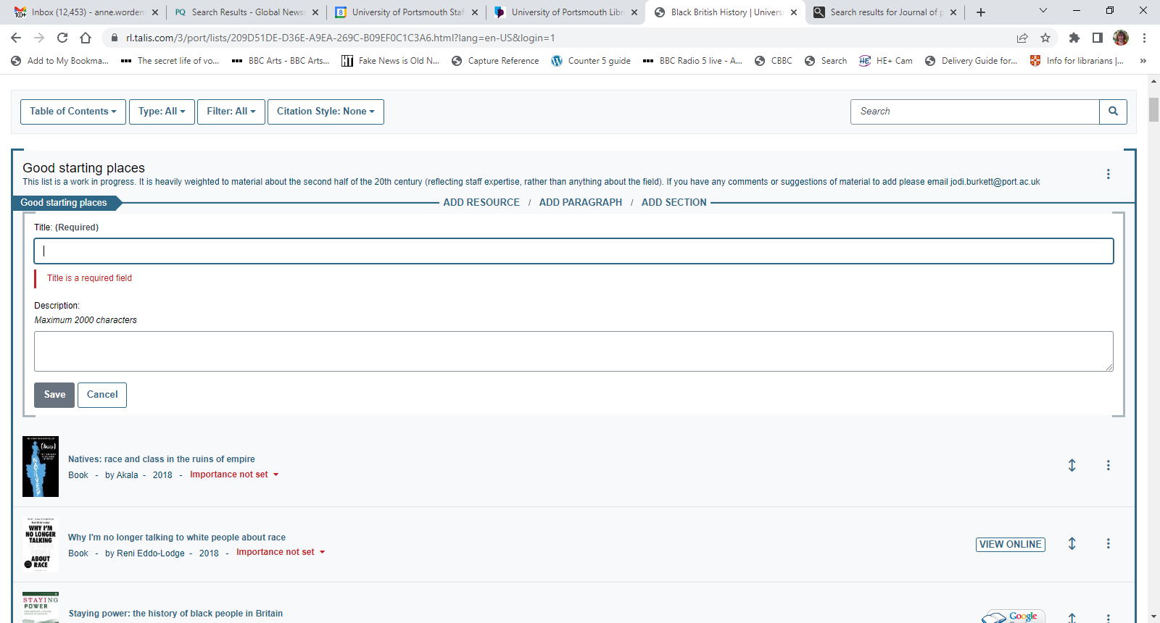

## 5.1 Adding books and e-books to your bookmark list

1. Start at the **library catalogue (not Discovery) – via the big blue button, at the top right of the library home page**  [https://library.port.ac.uk](https://library.port.ac.uk/) *You should only use Add manually for items not in the catalogue and which aren’t captured using the browser extension explained in 3. below.*
2. Search for the book you want and view the full book details, including the classmark or the link for online access (check the licence on an Ebook Central book in case it is 1 user).
3. With the full details on screen click **the jigsaw symbol for Extensions at the top right of your web browser** (if you haven’t added the Talis Aspire browser extension to the device you are working on, see bottom of p.1 of this guide).

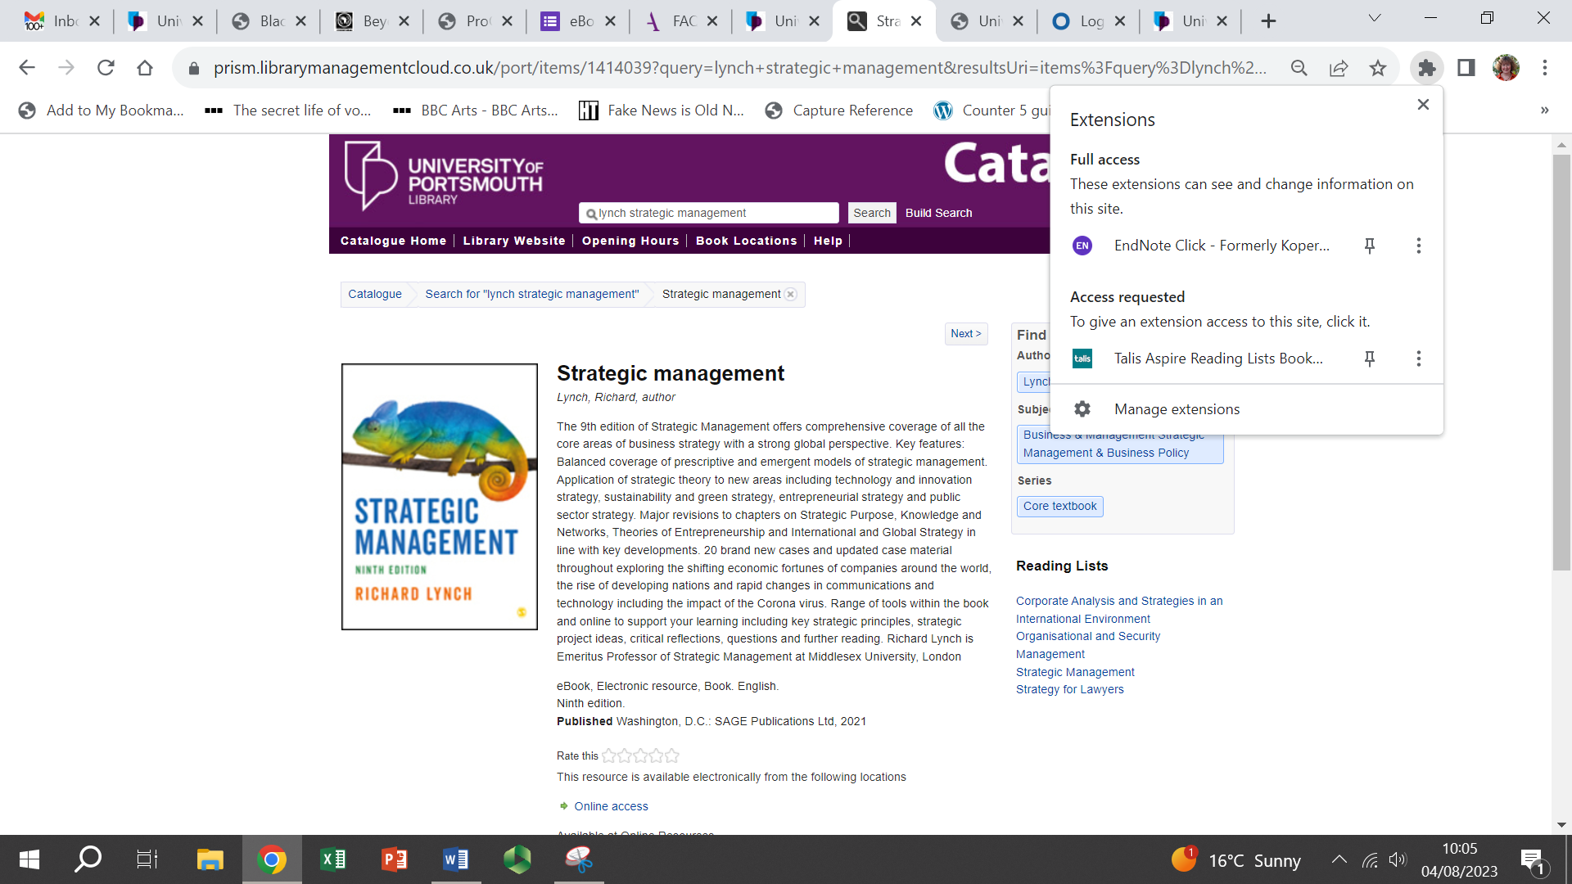

1. Select **Talis Aspire in your Extensions box**. You may then need to choose University of Portsmouth from a list and save that (this shouldn’t be necessary on subsequent occasions) before a screen like the one below appears.

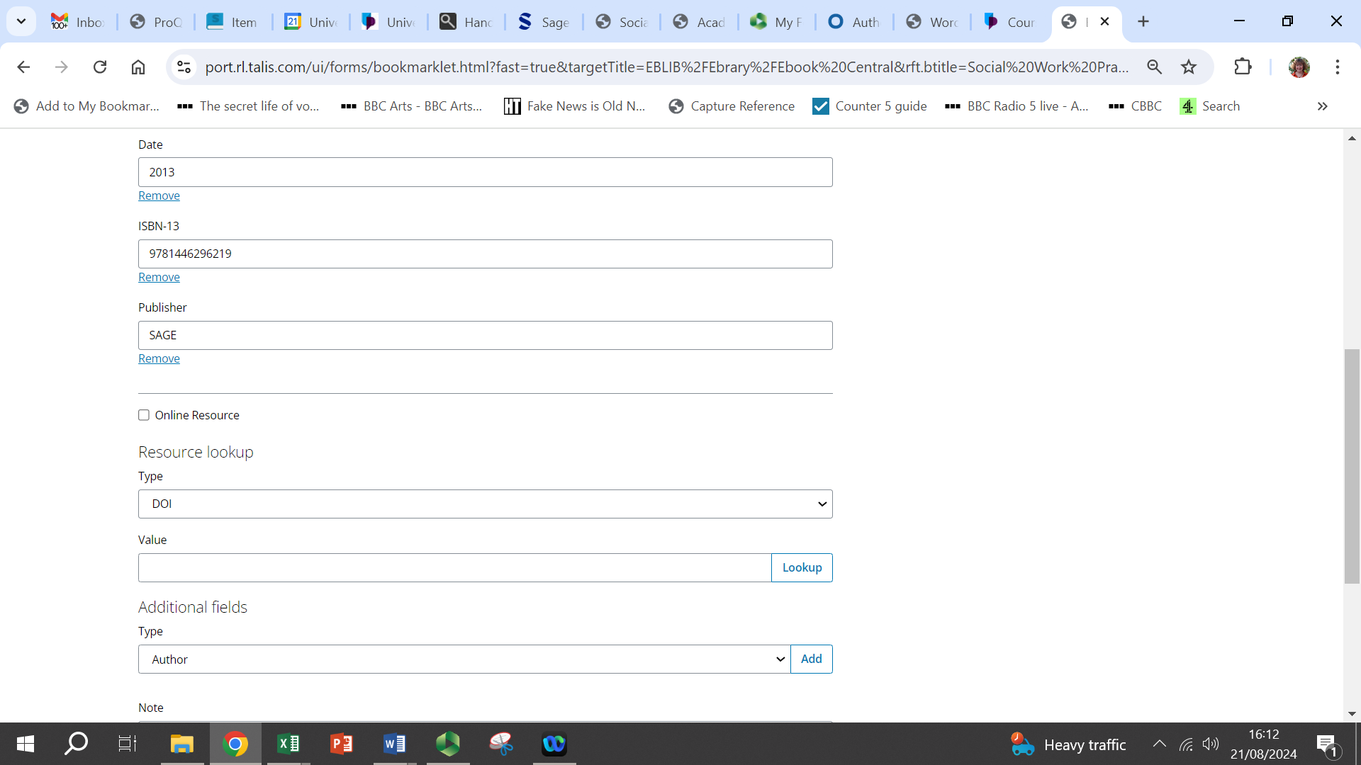

1. Here you can edit information about the book. Details should be captured automatically but it’s worth doing a quick check.
2. **Add any missing categories** by clicking the arrow at the end of the box saying Author under the **Additional fields** heading (see screenshot above). Select the field you need, then click **Add.** Note that **you may need to do this when capturing e-books or other online resources – always check at this stage that there is a web address or DOI showing in the Aspire record and if there isn’t, use the arrow** in the **Additional fields Author box** to select **Web address:**

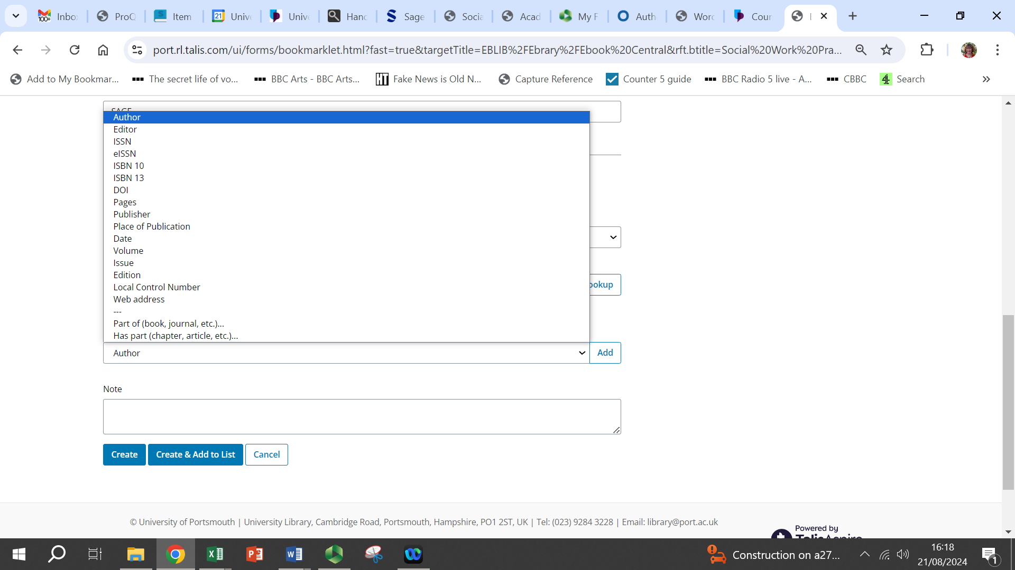

Once you have clicked **Add**, a new line will appear where you can add the URL and once you’ve done that, you should **click the small box next to Online Resource** (see below). After that an **extra box pops up** asking you to confirm the link you have just entered:

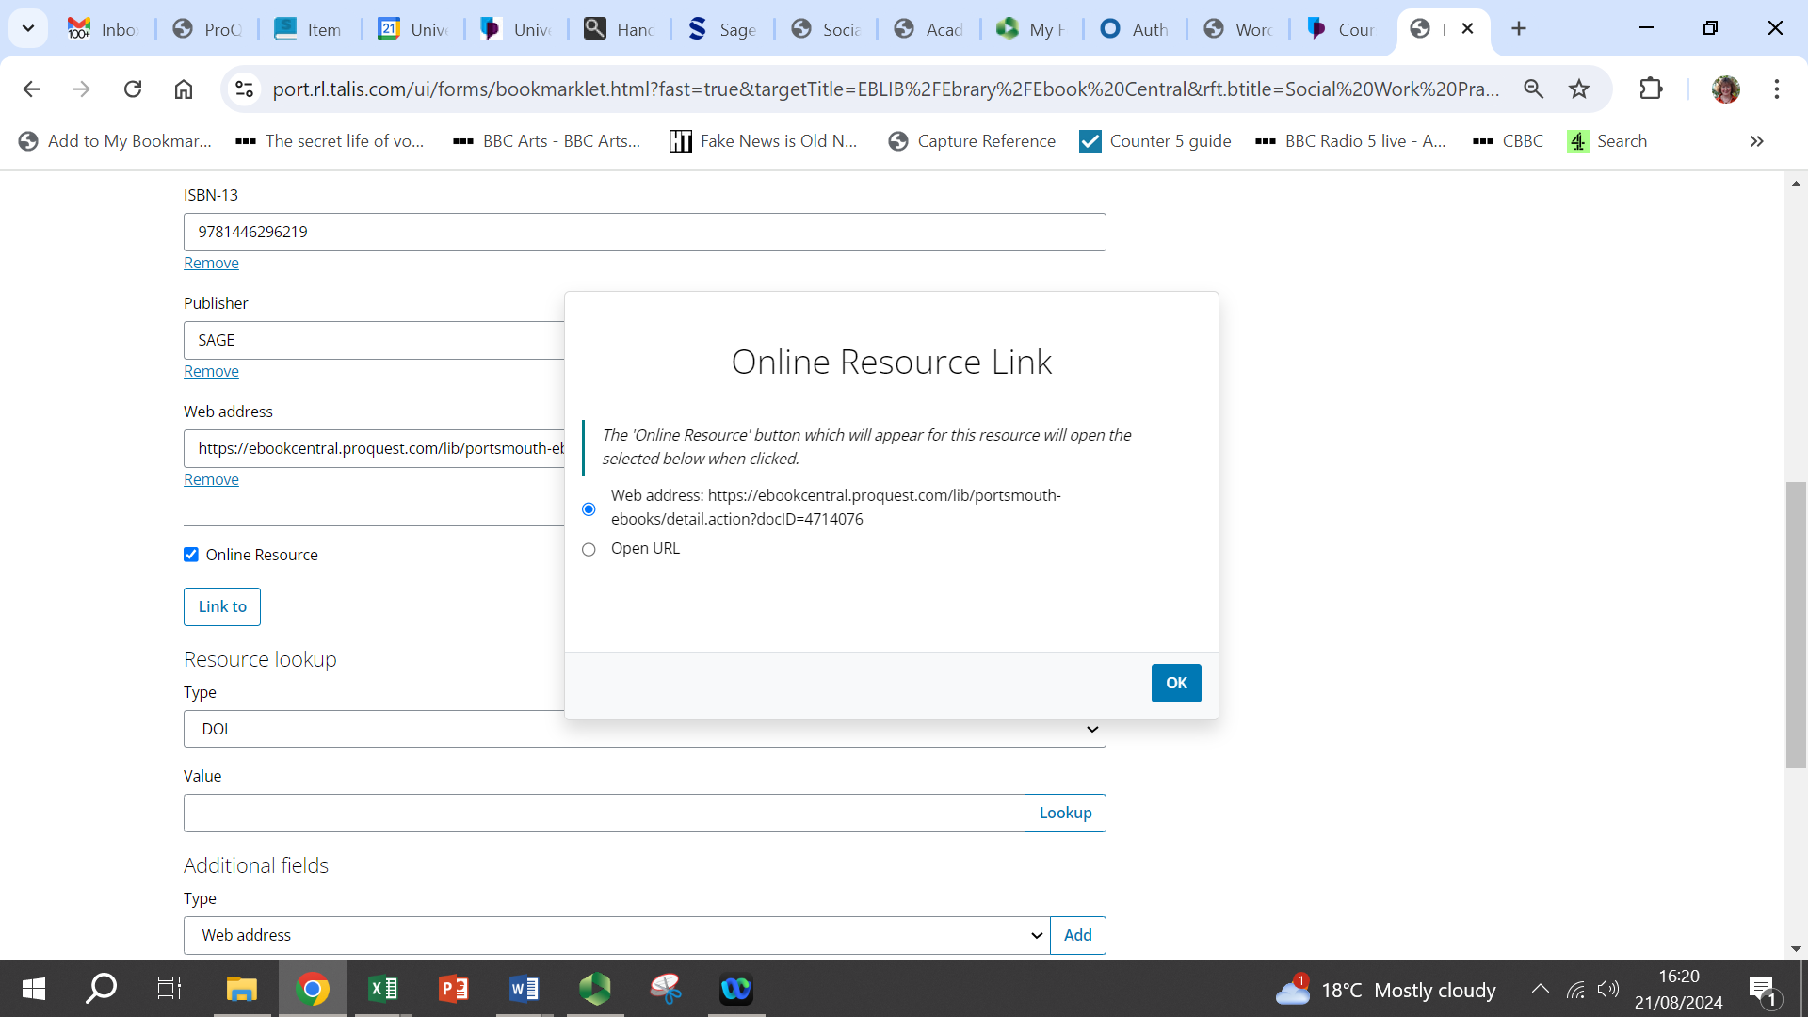

1. Add **notes** in the big box near the bottom. The library has found that students tend to engage more with books which have study notes explaining why the book is useful.
2. When you are finished, click **Create** or if you only have a few reading lists, **you may prefer Create & Add to List** which lets you choose to add an item to the top or bottom of a section on a list.

## 5.2 Adding bookmarked items to your online reading list

1. If you don’t already have your editable list open, go back to **My Lists** (top left of the screen) and click your list.
2. As long as you are logged into Aspire (your name appears towards the middle of the bar containing My Lists, My Bookmarks etc), whenever you scroll through your list, you will see **a long line appear across the screen**. This contains Add Resource, Add Paragraph and Add Section. To add a bookmarked item to your list, click **Add Resource**.

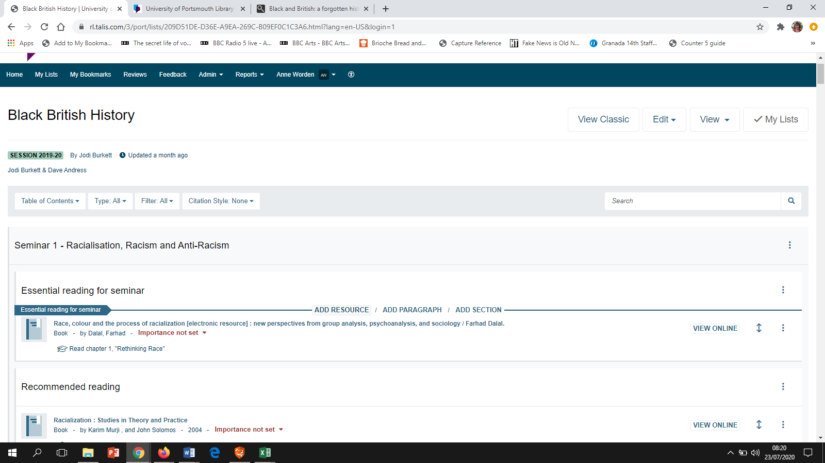

1. When you click Add Resource, **a list appears** containing any books, journal articles etc which you have bookmarked using the Talis Aspire browser extension. Just click the one you want to make it appear in your reading list.
2. If you want to **change the order of items** as your reading list grows, **use the double-headed arrow** at the far right of each line or click the 3 vertical dots to be able to cut and paste for longer moves.
3. If you want to add **notes for students** and didn’t put them in at the bookmarking stage, you can add them now by clicking the **3 vertical dots** at the end of each line. A drop-down appears containing a variety of options and **Notes for students** is about half way down.

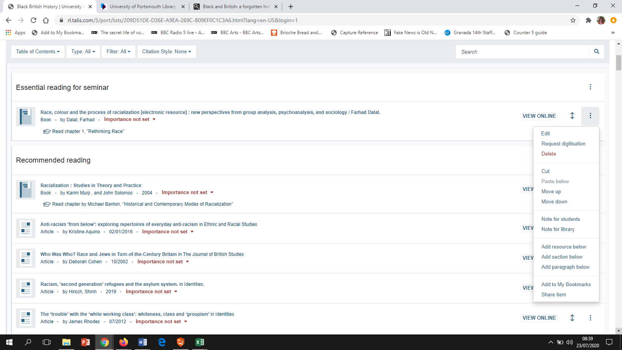

1. Notice that you can also leave **Notes for library**. We will pick up your notes at the **review stage but you must request this** (see section 6 on p.8)**.**
2. When you have added resources and finished working on the list for the time being, click **Publish** near the top or bottom right of the screen – extremely important if several of you need to work on the same list. Also, students don’t see changes until you’ve published.

## 5.3 Adding book chapters

1. Find the book containing the chapter on the **library catalogue.**
2. When the record has opened use your **Talis Aspire browser extension.**
3. Look back at the screenshot in step 4 of section 5.1. Under the **Additional fields** heading near the bottom left of the screen open the list using the arrow at the end of the Author box and click **Has part (chapter, article etc).** Click the **Add** button.
4. You now need to scroll towards the top of the screen where you will see the heading **Resource Type (Required)**. In the box below this heading, use the arrow to choose **Chapter**. Above this box you will see **Is part of Book**. Once you have added your chapter details, click Is part of Book to check the information about the (e)book is complete. In the Chapter section add:

* Chapter title
* Author of the chapter (if it’s different from the book author)
* Page numbers

1. When you are done click the **Save** button near the bottom of the screen. This has created a bookmark that you can add to your reading list using Add Resource as described in section 5.2.

## 5.4 Requesting a digitisation (scan) of a chapter from a print book

Within your reading list, you can request a digitisation of 1 chapter - sometimes 2 - from any book if we do not have the title as an e-book. Note that American, Italian and Indian publishers are less likely to give permission. You can get an indication of whether your request is likely to be successful by using the Copyright Licensing Agency’s Check Permissions Tool: <https://www.cla.co.uk/checkpermissions>

1. To make a request, just **click the 3 vertical dots at the far right of the item** in Aspire and you’ll see **Request digitisation** 2nd on the list.
2. Click Request digitisation and fill in as many details as possible. Once complete, the **scanning process happens automatically**, either via UoP Library or the British Library, and the **digitised chapter will appear automatically on your Aspire reading list.** You will also get an email confirming the digitisation is available.

Please note that **this is the only way you can legally make copyright material** **which is only published in printed form available to your students online**. The UoP licence says that all scanning must be done this way so that it is reported automatically to the CLA. **You must not scan something yourself and put it on your Moodle site**.

## 5.5 Adding a website or webpage

1. Go to the website which you want to include in your reading list.
2. Click **your Talis Aspire browser extension** (see section 3 on p.1 if necessary).
3. Under the field labelled **Resource Type** it should say Website or Webpage. If it doesn't, click the arrows to make the drop-down box appear and select your choice.
4. Include the following, plus a date if possible:

* The title of the website – you may need to edit so it makes sense
* The internet address
* When you are done click the **Create** button.

1. You can now go back to your reading list and click **Add Resource** at the place in the list where you want to add the website.

## 5.6 Adding e-journal articles

1. Go to **Click to search Library resources** at the **top right of the library home page**. On the next screen, go to the 1st box, click **journals** below the search box, then type the e-journal name.

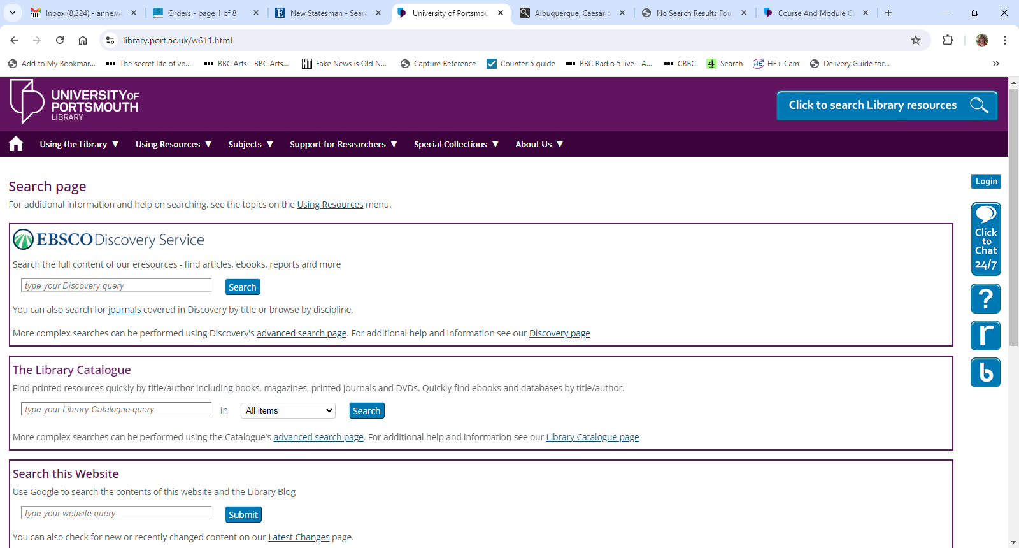

1. When the results appear, click the publisher link which covers the year you need. This should take you to the publisher’s website.
2. Browse or search on the e-journal page to find the article you are looking for. When you have found it, look for the page that shows a summary about the article or just click the article title. Click **your Talis Aspire browser extension** to capture the details (see section 3, p.1 if needed).
3. **If you are in Discovery, you need to click the 3 vertical dots to the right of the article title** to get something similar to what is shown below. Click the **Share** curved arrow, then choose **Create link** and copy the link which appears (see 2nd screenshot below), **before you use the browser extension** to capture the article details. When the article details are on the capture screen, **replace the long web address** with the shorter link which you have just copied.

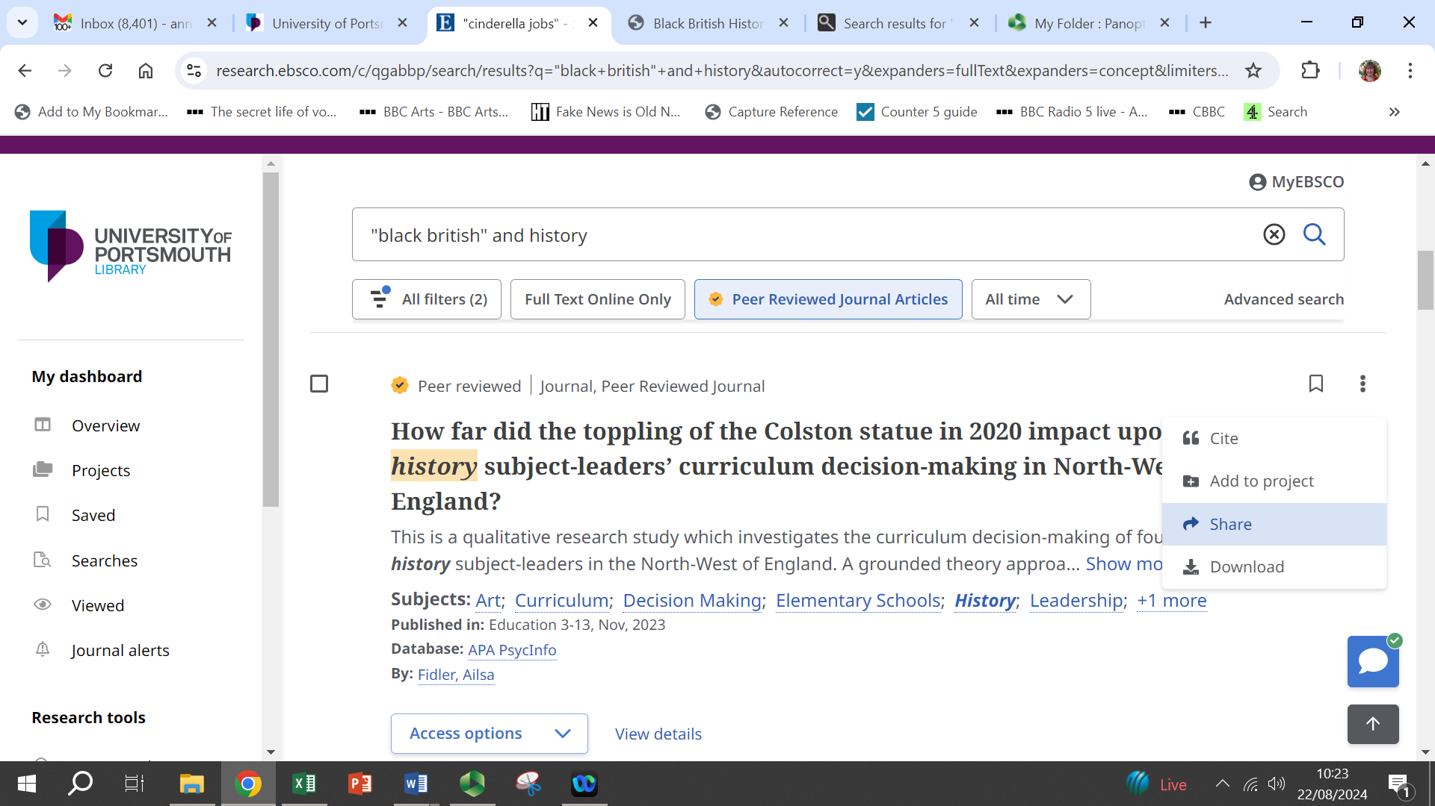

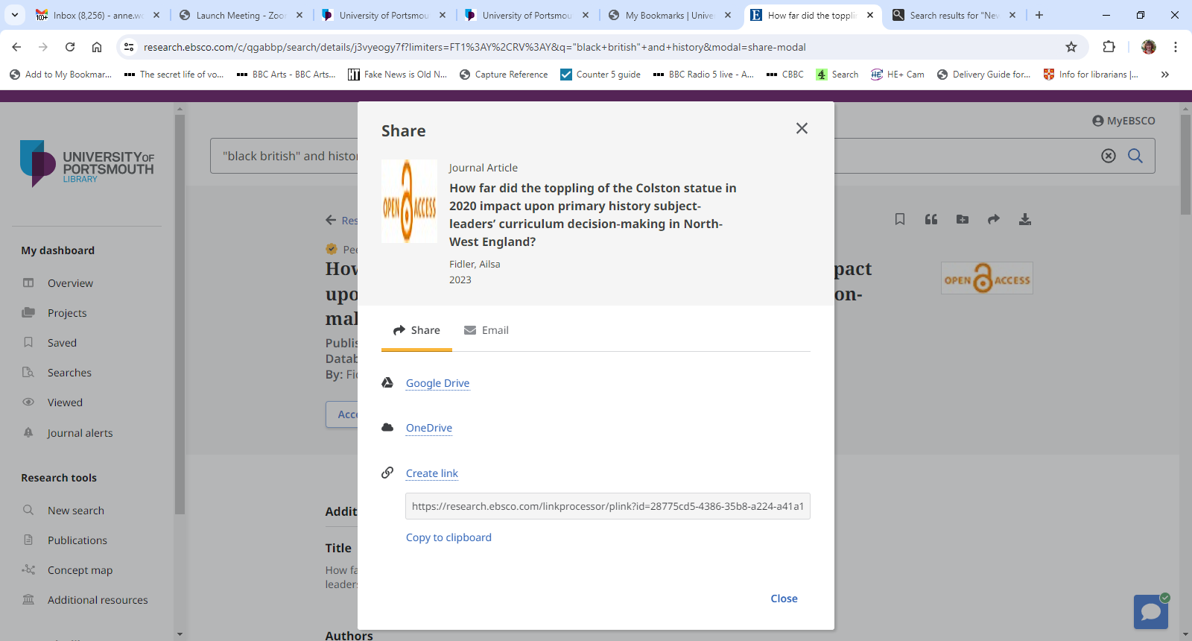

1. Check the information is complete. It is usually entered automatically but it is worth checking it is all there. **You may also need to delete surplus information, especially in the date field e.g. only the year should be present**. When done, click **Create.**
2. Go back to your reading list and scroll through so that you see the **line containing Add Resource**. Your bookmarked e-journal article should now appear with your other bookmarked items. Place the article wherever you need it on your list.

# Reviewing Your List

When you have completely finished your list, it is important that library staff review the list so we can check we have the books/e-books in stock and pick up any notes you have made for us.

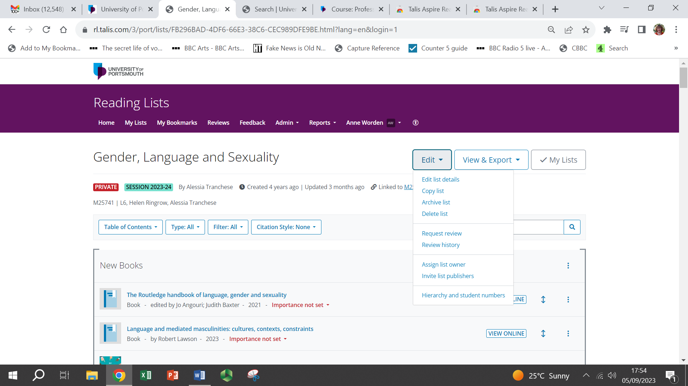

1. Click **Edit** (top right) to make a drop-down box appear.
2. Click **Request review**.
3. When the Request Review box pops up, click **Send.**
4. When library staff review the list, they will order items not in stock and check whether e-books are now available for any titles listed only in printed form. We will also act on any notes you have made for the library in your list.

# Dashboard – Seeing What Students Have Used

The dashboard feature gives you information that will help you make informed decisions about your list. It shows you information about the popularity of your list and how much use each item on the list has had in a particular time period.

1. To access the dashboard, start at the normal viewing page of your list. Go to the **View & Export** drop-down(top right), then click **Analytics**.

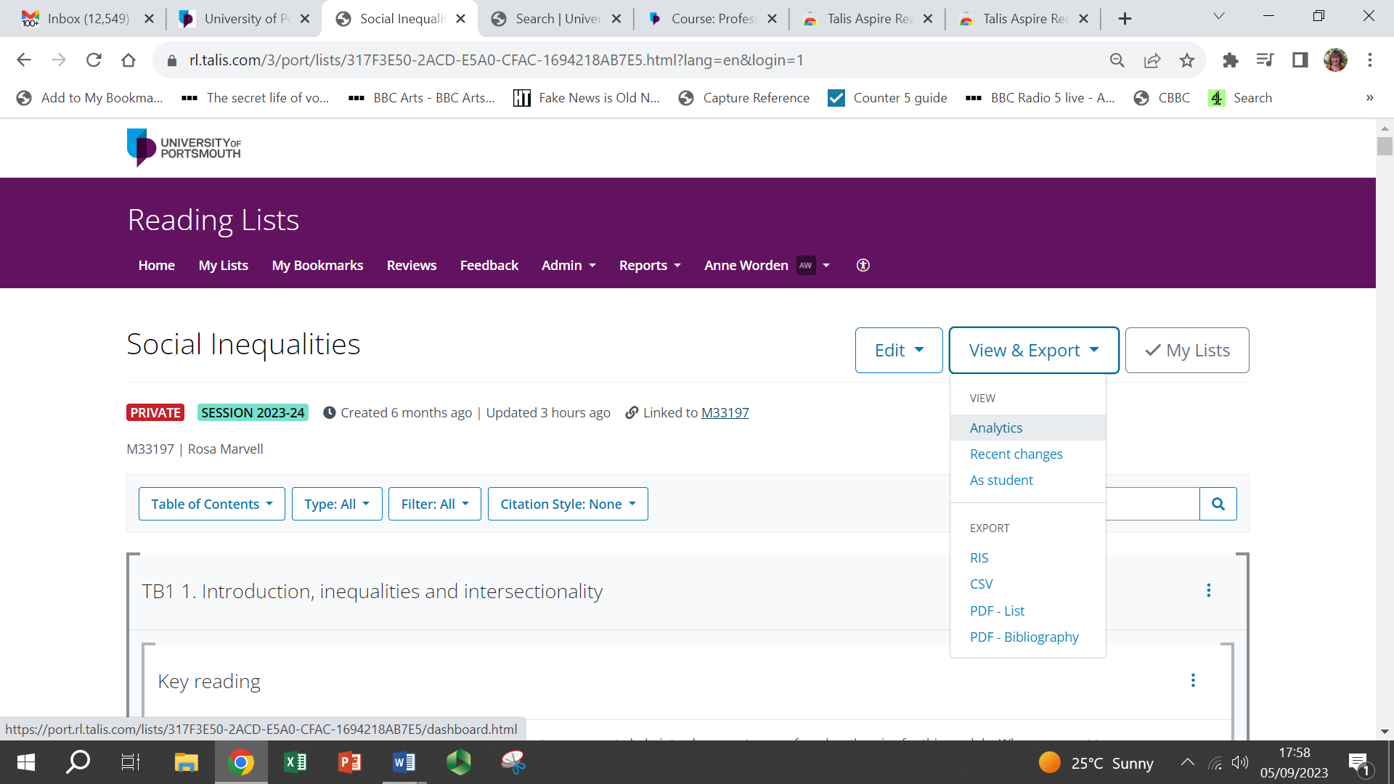

1. This will show you how many times your list has been viewed and how many items have been clicked on.
2. You can **change the date range** to show information over a period you choose. Click the dropdown arrow next to **All time activity** (on the left).

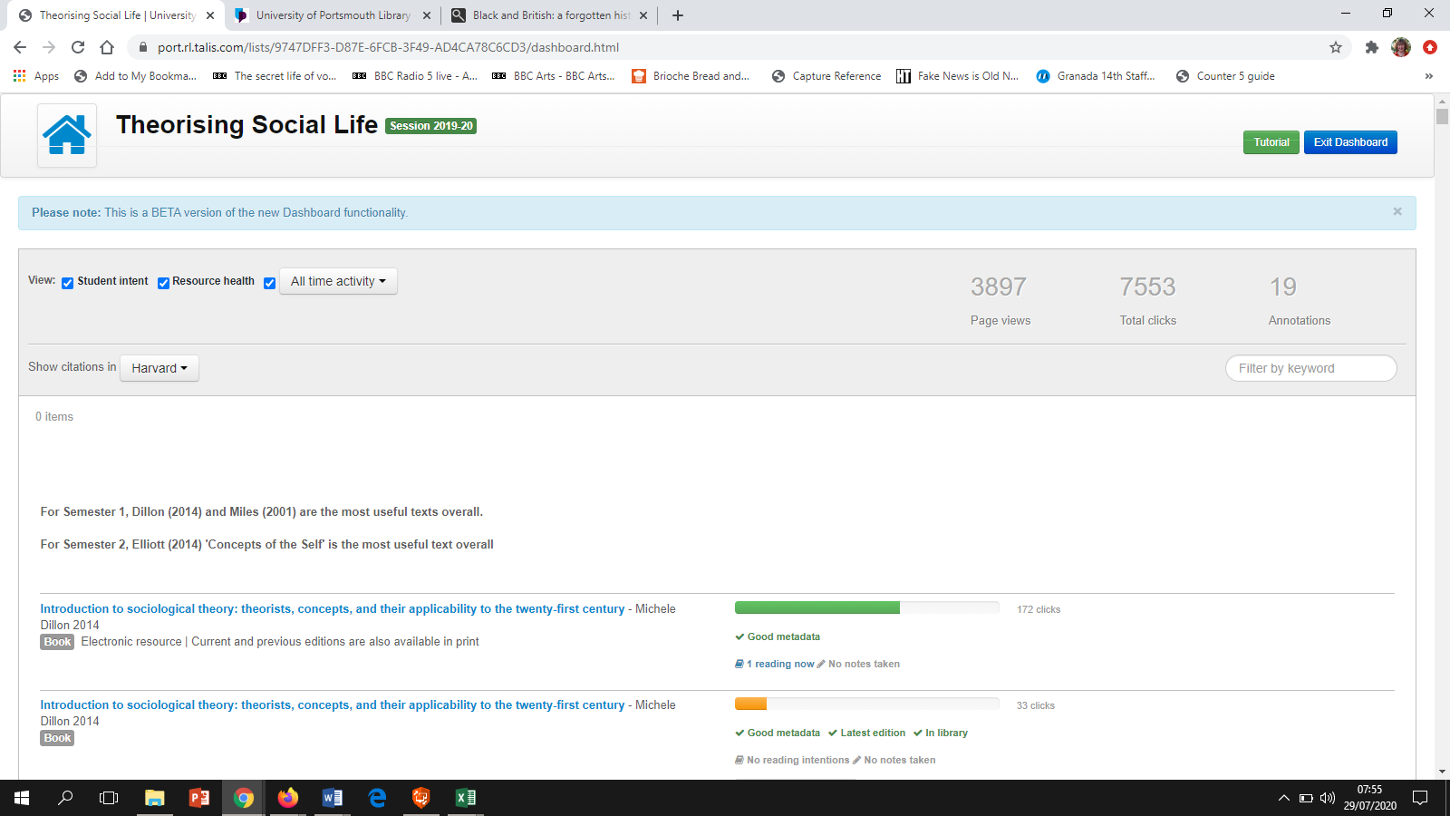

1. Next to each resource a coloured bar will appear indicating how much a resource has been used. If a resource has a green bar next to it, then it has high usage. However, if a resource has a red bar next to it, then usage is low. In cases like this, you may wish to promote the item by adding a note, moving it to a different place on your list or highlighting the benefits of the resource to students next time you see them.
2. The numbers next to the coloured bars indicate how many times the resource has been clicked. If you feel the resource should be used more, you can edit the resource to promote it.

# Embedding Sections of Your List in Your Moodle Site

1. **Make sure you are logged into Talis Aspire**. This video shows you the whole process of what you need to do if you want to watch before going through the steps on your own Moodle site:

<https://port.cloud.panopto.eu/Panopto/Pages/Viewer.aspx?id=bc305fe2-8d75-4ec8-b4f6-b075007141d6>

1. Go to the section needed in your **Moodle site**, making sure you have **turned editing on**.
2. Click **Add an activity or resource**.

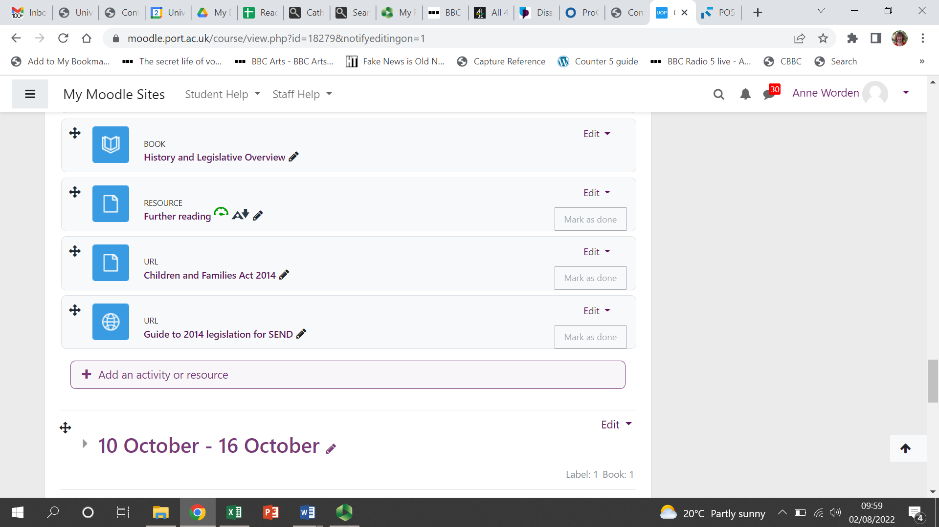

1. In the new menu which pops up, select **Talis Reading List**.

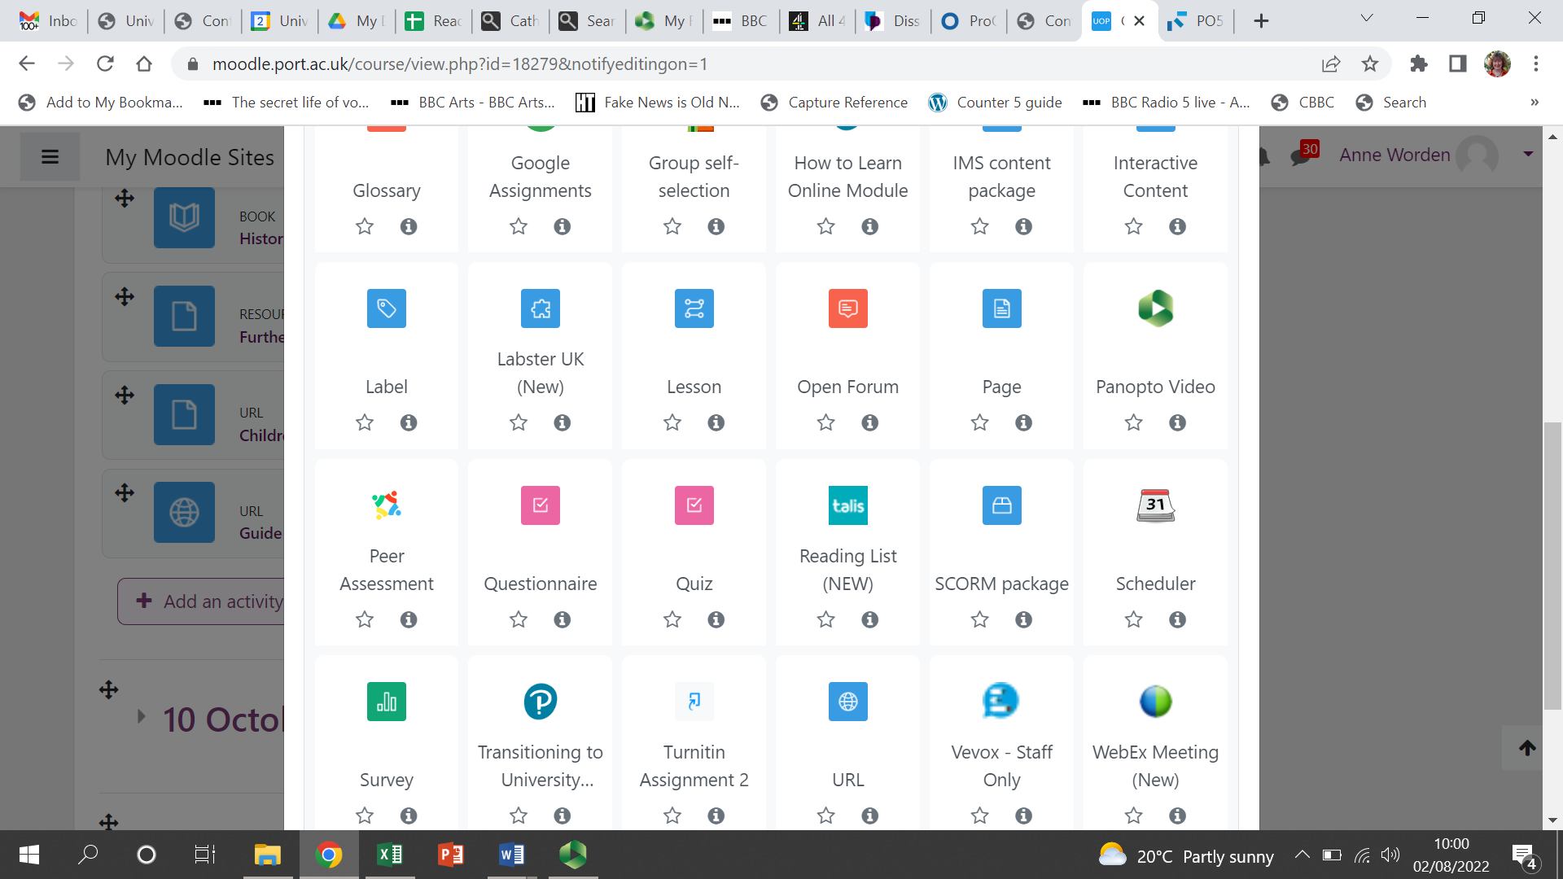

1. On the next screen you can see the **Activity name** box where you will type something meaningful e.g. Week 2 Essential Reading but **ignore that for now as whatever you type will be overwritten when you take the next steps**. Instead, click the **Select content** button.

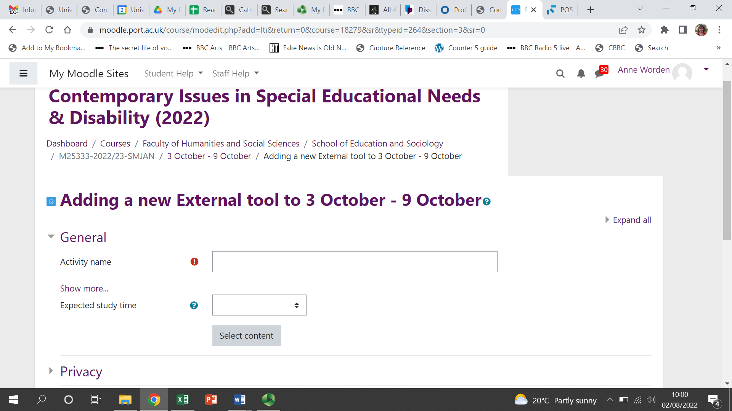

1. At this point, the name or module number should appear under Suggested lists. If the name or number is not visible, you can start typing them in to pull the details in from Talis Aspire.

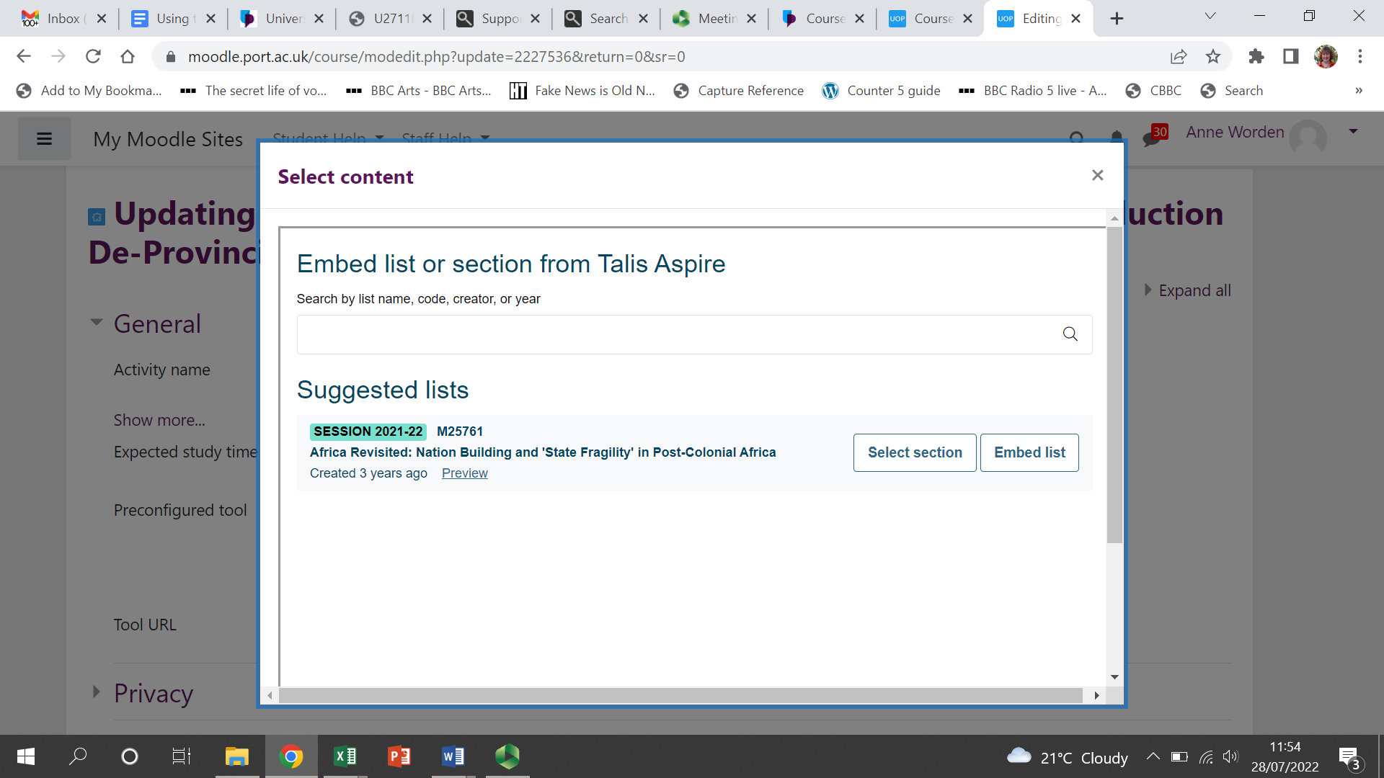

1. You can add the whole reading list by clicking **Embed list**, or **to add just 1 week’s reading** (or a particular themed section from your reading list) into a weekly section on Moodle, choose **Select section** (see screenshot above).
2. If you choose **Select section**, you will then see a screen like the one below which has pulled in the Table of Contents from the Talis list. Choose the appropriate section for the place you are at in Moodle and **click Embed section** (notice the **Preview link next to the section name** – this lets you see what you are about to embed):

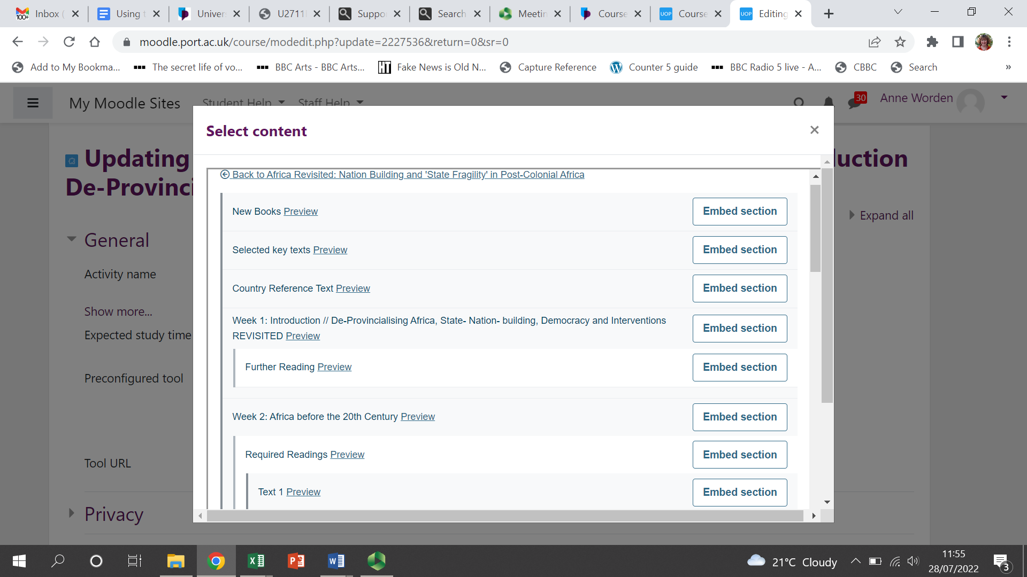

1. Once you’ve clicked Embed section, you will return to the screen with the Activity name box. You will see that this box now says Talis Aspire plus the section and module name as in the next screenshot. **You can replace this with something shorter and more meaningful**, e.g. Week 2 Essential Reading.

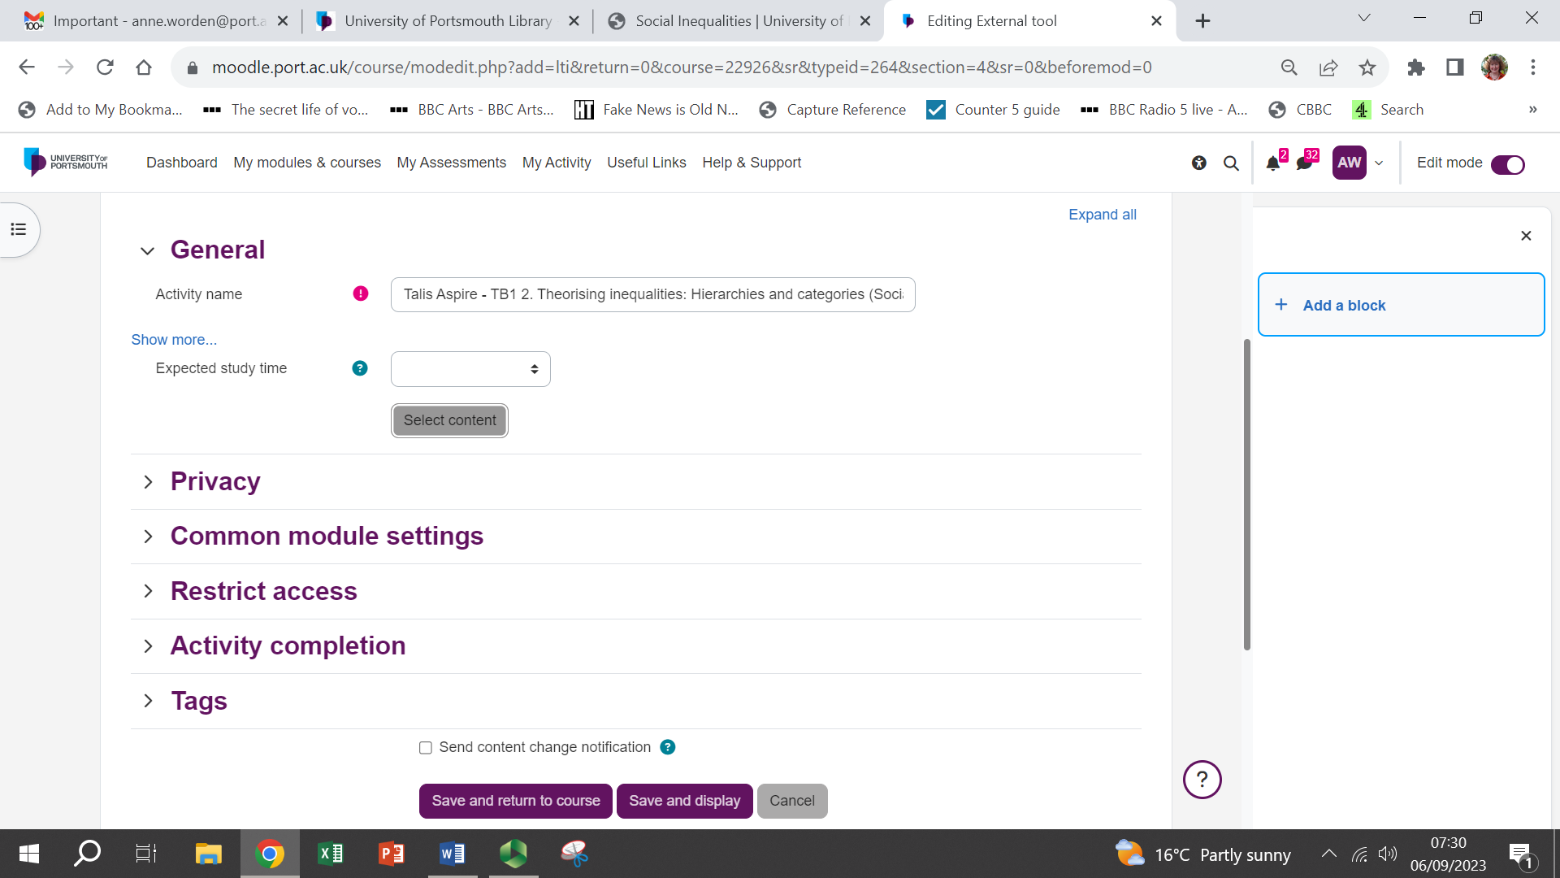

1. Once you have put the section name in the Activity name box, you can click **Save and return to course**:

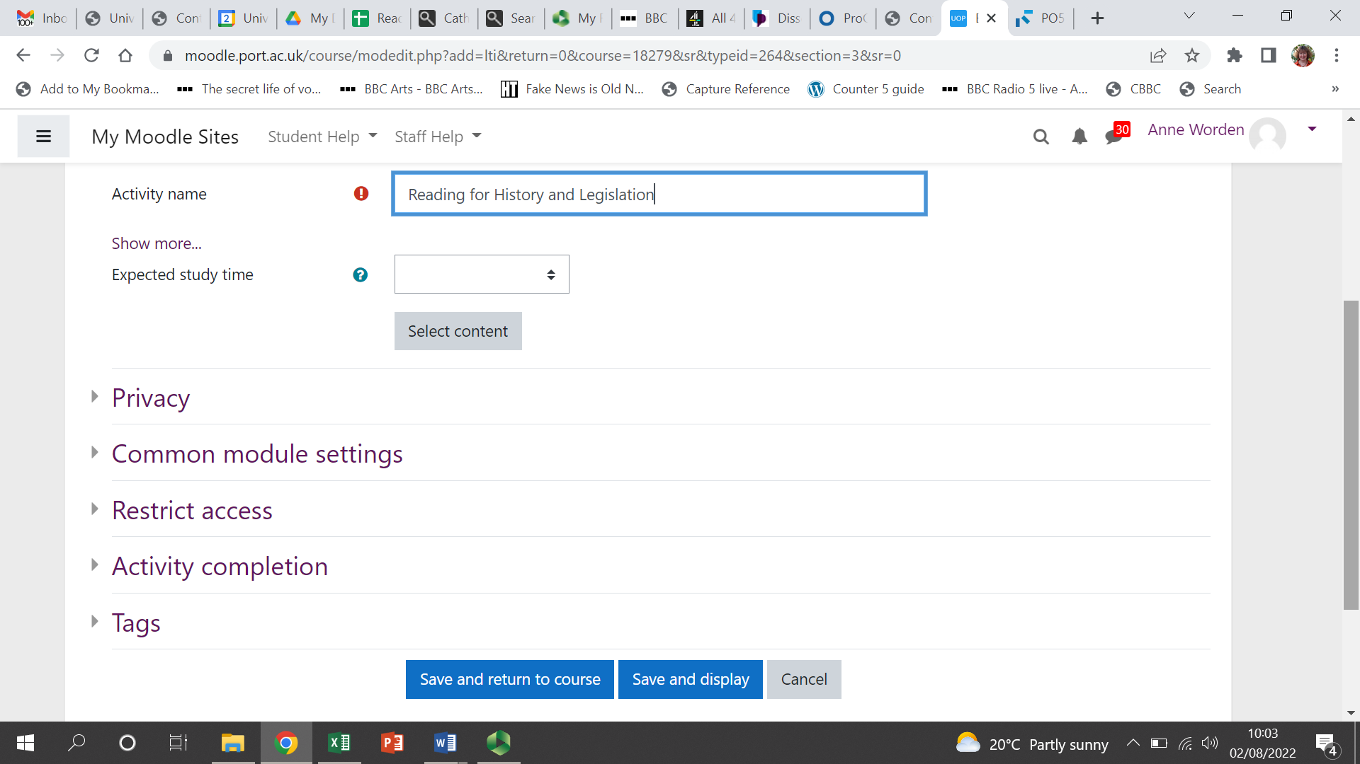

1. You should now see a Talis block embedded within your weekly section on Moodle:

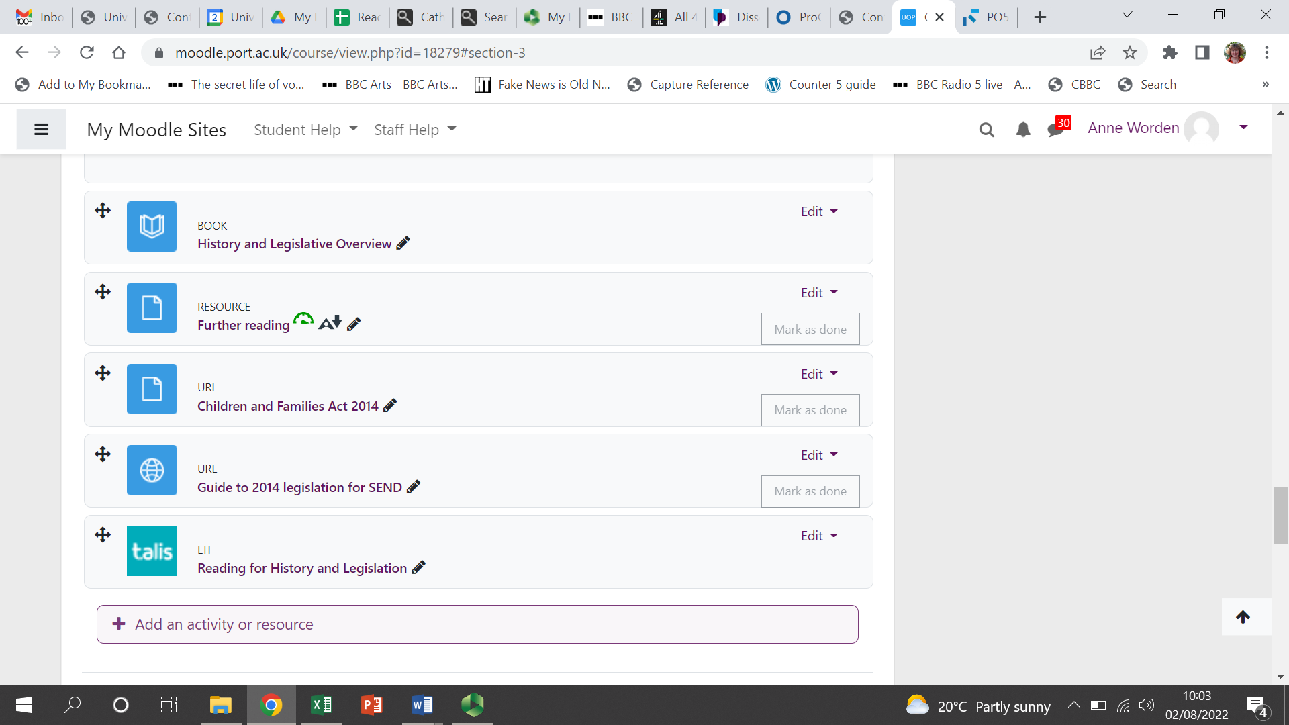

Clicking the section name next to the Talis block should then open up just that section of the Talis Aspire reading list. If you get an error message on screen instead of the list, it is almost certainly because you aren’t logged into Talis Aspire (this will be true for students too), so log into Aspire and then the reading should appear.

August 2024